Start Document for Empires of ages

**Developers:**

Alex van der Kroft

Matteo La Barbera

Vasil Ivanov

Maté Soos

Levi Stieber

C#2 Start Document

By: Team BattleYa

Indie BattleYa  NHL Stenden

# Idea

The main idea is based on the popular game franchise "Age of Empires". Our main idea is to have an interactive map that is 2D from a top-down perspective. The game is based on historical battles and campaigns, for example, the battle of Hastings. This would be done through multiple mechanics, but the main idea is that the user is capable of producing troops utilizing resources, these resources are produced by villagers. These villagers can be made in the "Base"; however, these villagers of course need food to be produced. The user is given a "Base" at the start, or multiple depending on the scenario. This base can do multiple things, depending on the faction. For example, a "French" faction would be capable of using the base to, besides producing villagers, also upgrade their archers to crossbowmen. And, as another example, the "English" faction would be capable of upgrading their wood production and producing longbowmen.

The map would be produced at the start, hardcoded in our original design. This map would have resources spread out, the main resources would be food, wood, stone, and gold. These are all utilized for specific constructions and troops, for example, a villager acquires food by working at the food resource, this food can be used to either recruit new villagers from the base. This villager could gather stone from the mine, which could be used to construct a "barrack". This barrack, using food, could produce troops. For example, the "English" faction could produce pikemen using these.

Every faction in the game should have its selection of troops and mechanics that would be selected only for them, which has been hinted at in the entry of the idea. The main goal is a total of at least one faction being fully playable, having at least 2 factions. These factions would be, Blue and Red and in the future the English, the French, the Hungarians, the Germans, the Italians, and the Greeks.

A few examples of the future version of the game that unique mechanics would be that the Hungarians while having weak archers and no artillery, would have stronger cavalry than any other factions. Due to being raiders, they would start with a larger force than the enemy but be unable to construct more due to not having a base. While, in this case, the Germans would start with a base, but a smaller army. The Germans would have stronger infantry and average archers than the other factions due to their focus on infantry in the Middle Ages.

Resources can also be utilized to unlock technologies, as factions can unlock better troops through the investment of food and gold, or iron and wood. For example, the Hungarians could make so-called "Raider Camps" which would spawn more troops to aid them using food and iron, and the French could produce a "Caserne" which would be able to produce pikemen and French knights. Other technologies could also be unlocked, like a "Saw" that could help villagers produce wood more quickly.

A player can pick either faction to play when a campaign is selected. This could be the French or English, or Hungarians or Germans depending on which campaign is picked. The player would spawn in with a few villagers and a base. The resources for both factions would be decided by the player or their selected difficulty at the start of the game. Then, the goal of the game would be to destroy the enemy's bases or camps (If the opponent is Hungary). This can only be done with troops, not villagers. These troops are of course made in the same way we previously discussed. In the idea. To win, a player could either attempt to ignore the enemy's troops and go straight for their base for an early victory or try to defeat their army first and surround their base for a decisive battle. When the enemy base/bases are destroyed, the player would win.

# Engine

The game will be built using a game engine. The creation of games can be very complex in terms of graphics handling, physics, and player controls and interaction. Therefore, a game engine will be used to assist us in the creation of empires of ages.

The game engine that will be utilized will be MonoGame and MonoGame Extended as this is a game engine that is popular and uses the .NET framework. As it is working with the .NET, it is fully open source so there are no subscriptions or license payments required to use the engine. The game engine also allows the ability to port the game to multiple platforms if it is required in the future. The development will therefore be able to be done using Visual Studio.

# Class Diagram

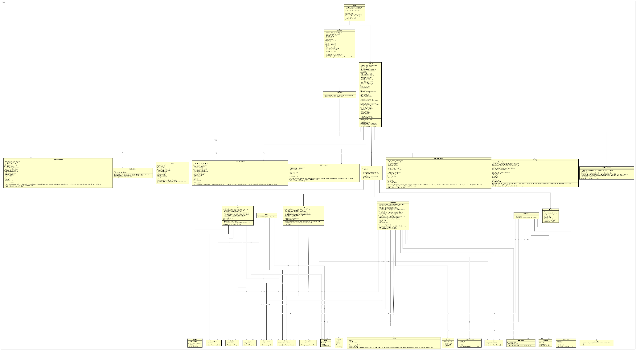

# Use Case

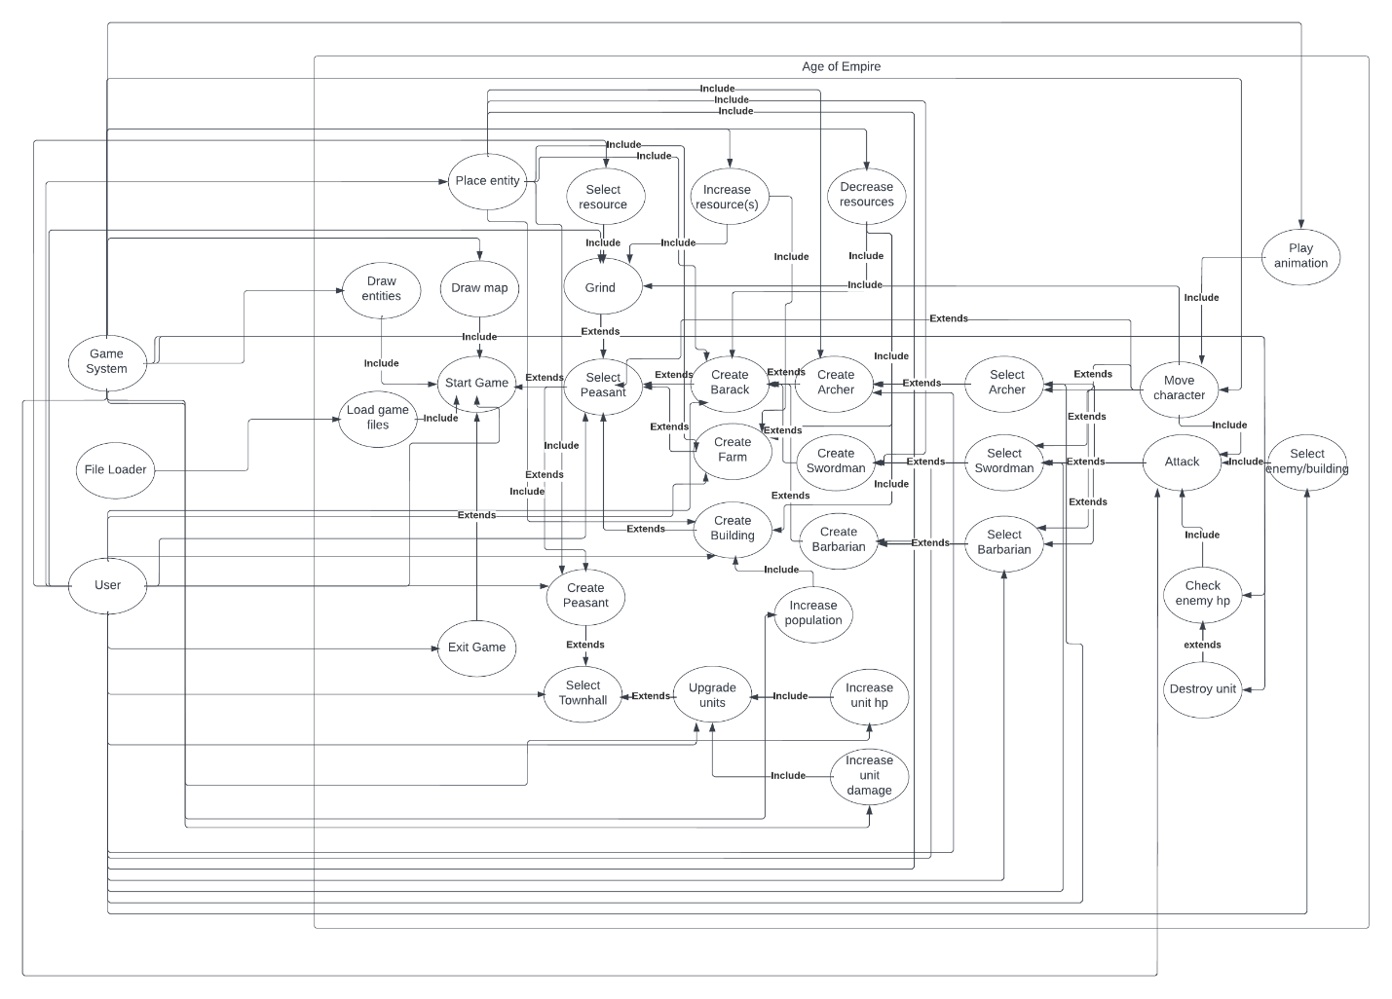

# Wireframe & User Interface Explanation

Here the Wireframe of the game will be shown, showing all game states and their proposed sketches in our design. It will be heavily influenced by other strategy games, like Age of Empires. Alongside the wireframe, will be a few UI sketches that our team has designed and might utilize in the project. This is also our user interface design in its whole.

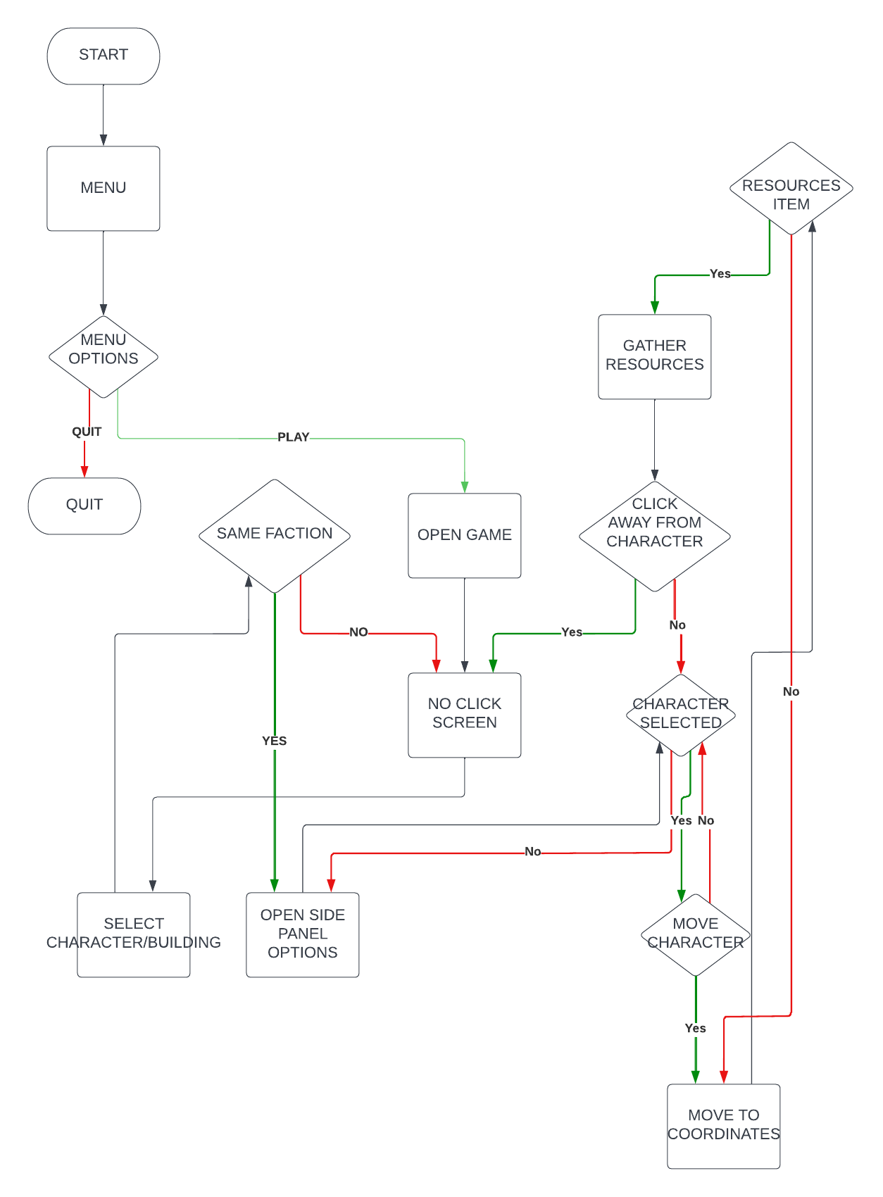

## Menu WireFrame

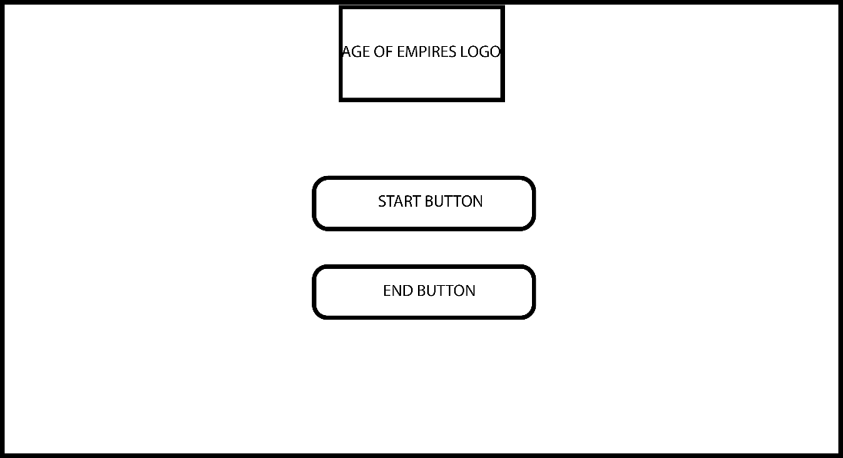

The Menu is the opening game for the page. The menu consists of the logo which is clickable to launch the game as well as a start button to enter the game and an end button to exit the game. They are centered by width.

### Menu

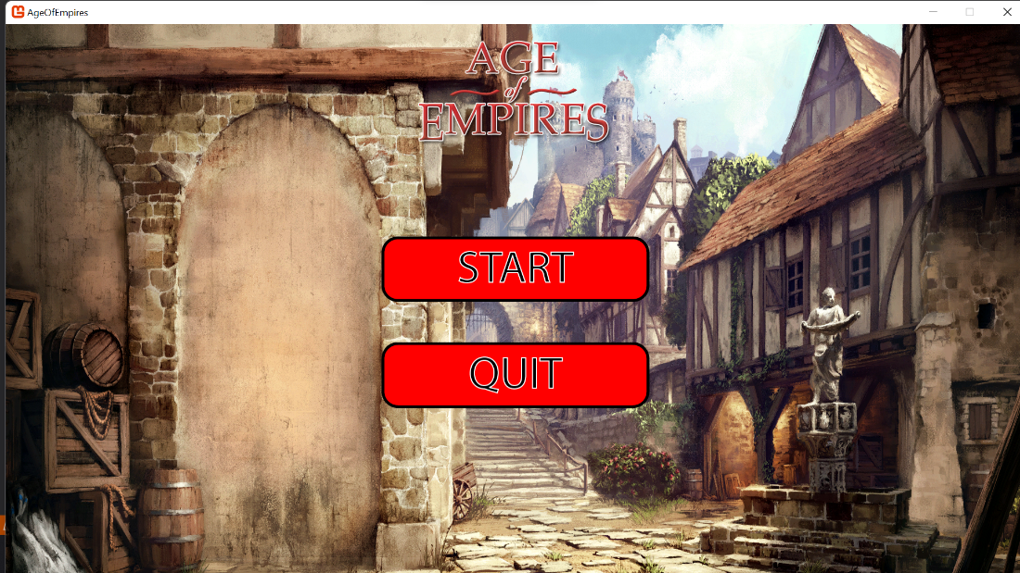

This is the wireframe for the menu, it is a rather simple menu. There is a background picture which occupies the entire background, like the picture in our sketch. There are only two buttons that the player can utilize in our demo, a "start" mode button, which will redirect the player to the game. Alongside an exit button, which will of course make the player exit the game.

## Game WireFrame

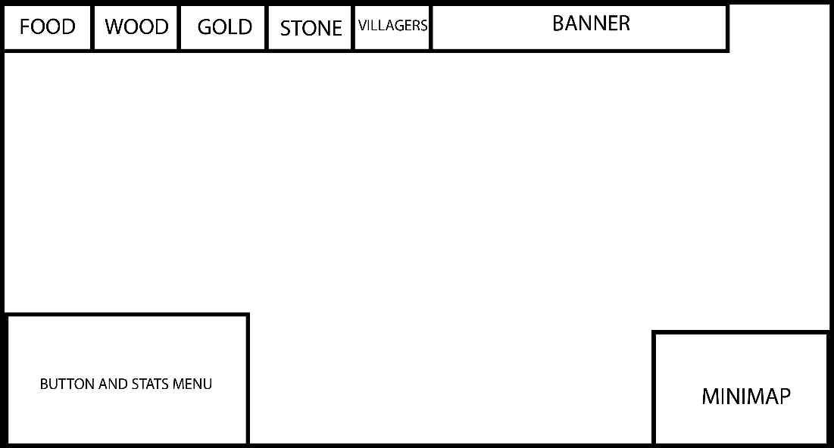

This is the game wireframe, which explains the idea behind our game, as shown here, wood counter, iron counter, food counter and gold counter in the top menu. This is to keep track of which nation you are playing as, as well as a counter for which resources you have.

In the bottom right, the unit menu is there. This is only there for when a unit or entity is selected. This allows the player to make them build specific buildings, look at their abilities and look at their health, attack and defense alongside their name. At the bottom right, the mini map is there, which shows the player what they have discovered in the actual world.

### Game

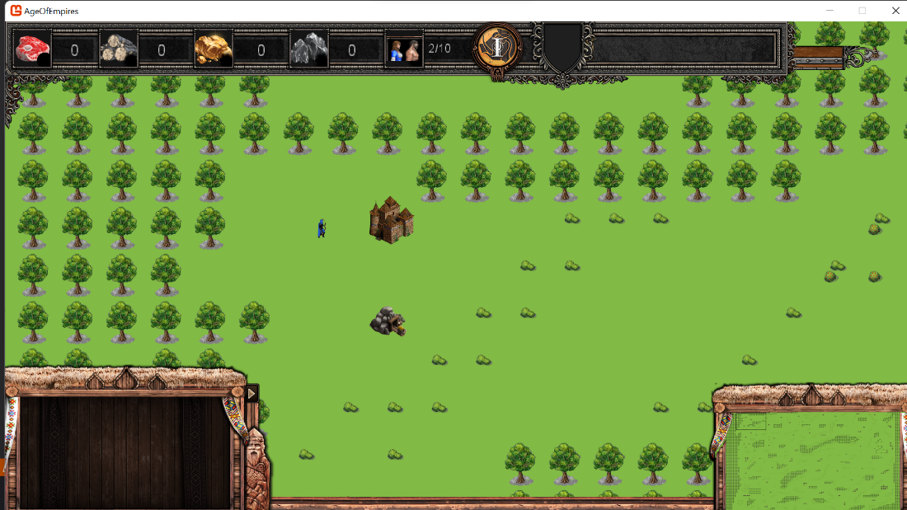

This would be an example of a screenshot out of the game, with units being on the game sheet with an area around him, including forest and plains for now. This would differ based on each campaign. Of course, buildings and animals would be added in future designs. In the user interface, the characters would be able to be moved and assigned to tasks across the map, as well as build buildings. Buildings would be able to produce units in turn. But would put their sprite on the map.

# Menus

## Army unit

### WireFrame

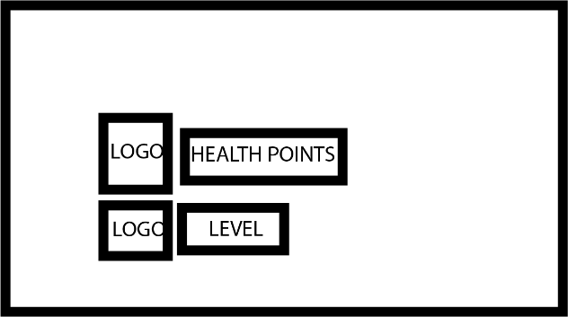

This is the wireframe for the Army units. It displays the health and current level that the unit is currently at.

### Image

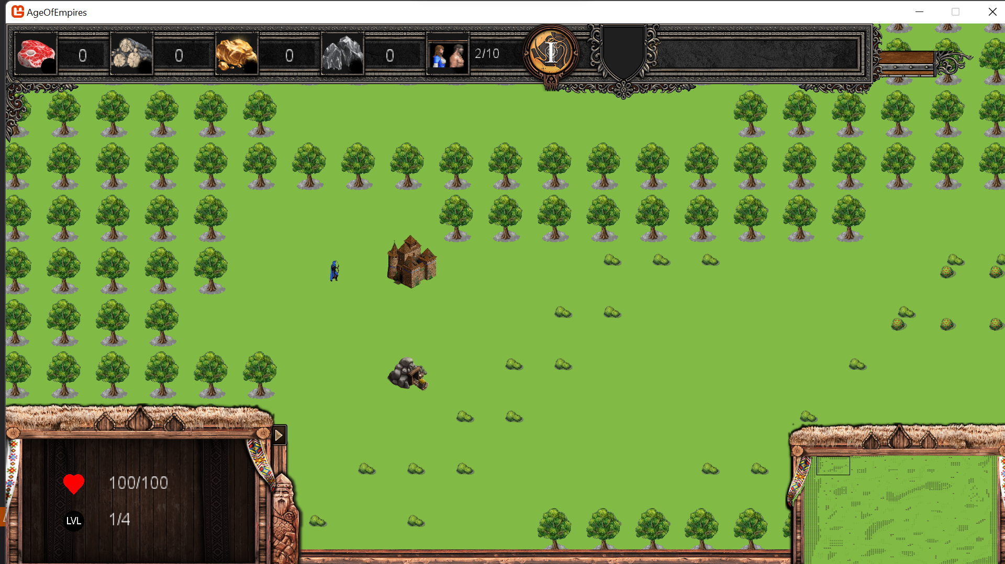

## Villager

### Wireframe

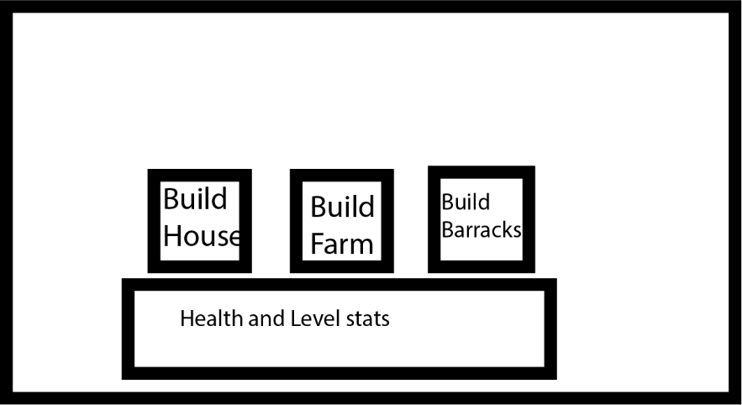

This is the wireframe when a villager is selected. The villager has the ability to build a house, a farm and barracks. These buttons only show when a villager is selected. The health and level of the villager are also shown.

### Image

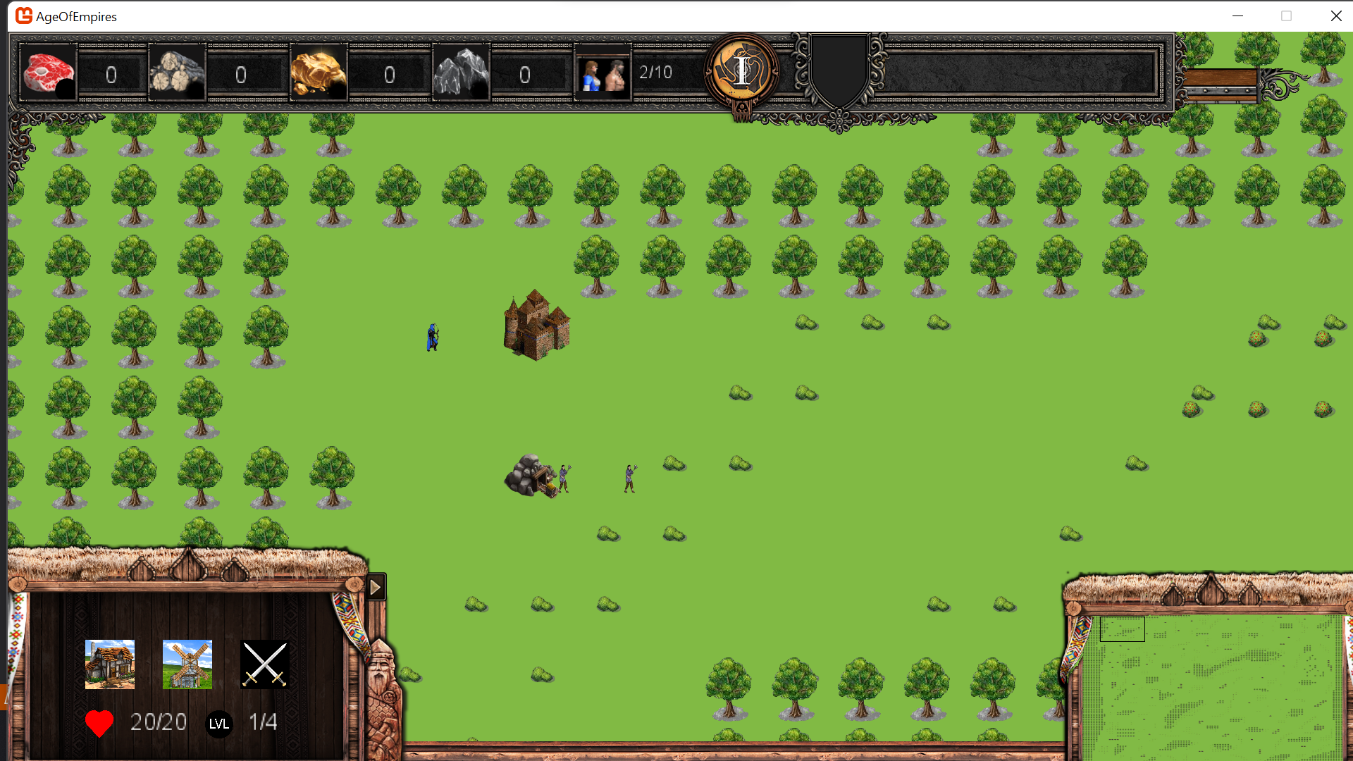

## Townhall

### Wireframe

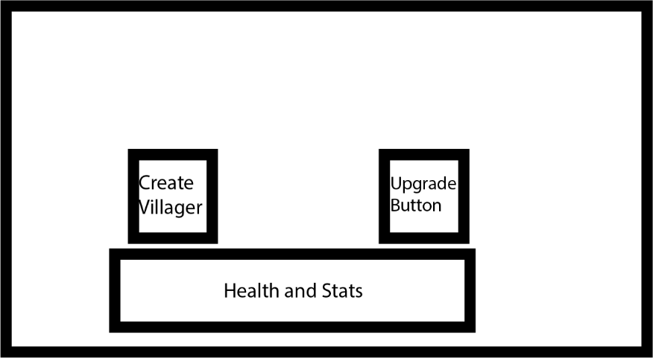

This is the wireframe for the town hall selection. The town hall has the ability to create villagers and also upgrade all the stats as it is the head of the village.

### Image

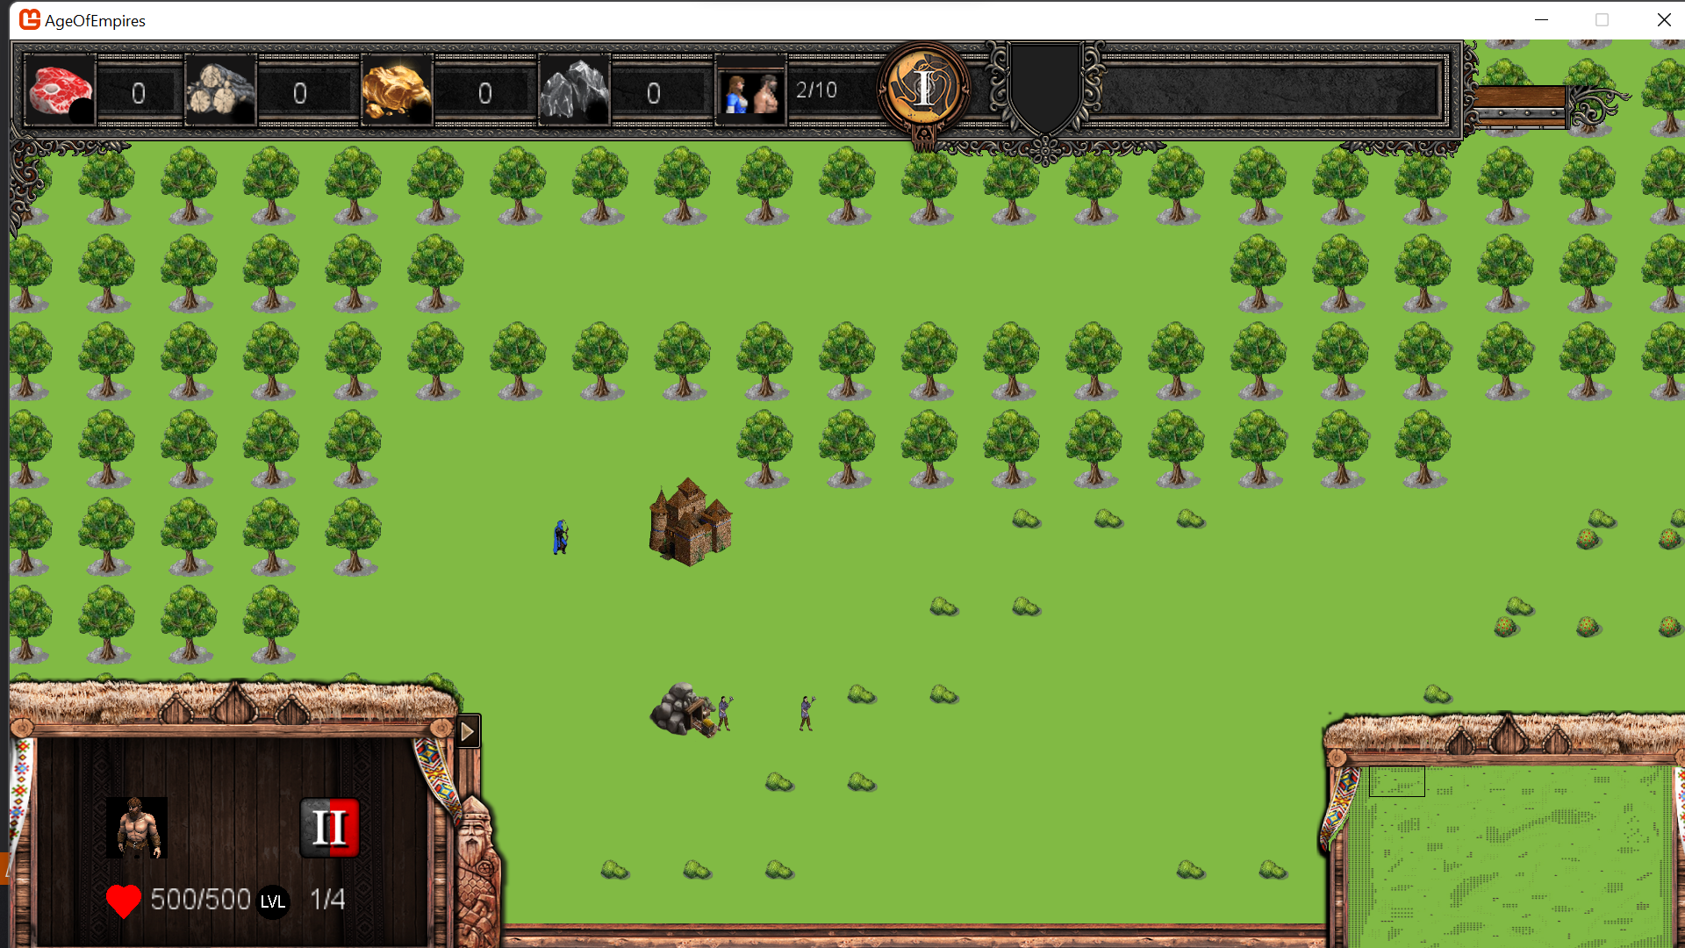

## Barrack

### Wireframe

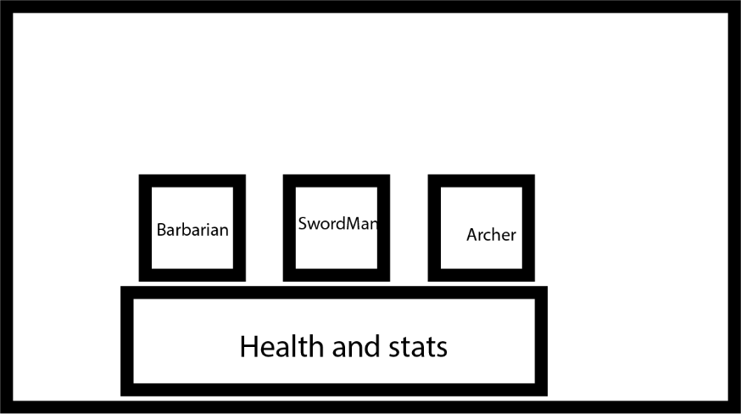

This is the wireframe of the barracks. It allows the creation of army troops. These consist of the barbarian, swordman and archer. These buttons will only create the troops if all the necessary resources are available. There is also a display of the building’s health and level.

### Image

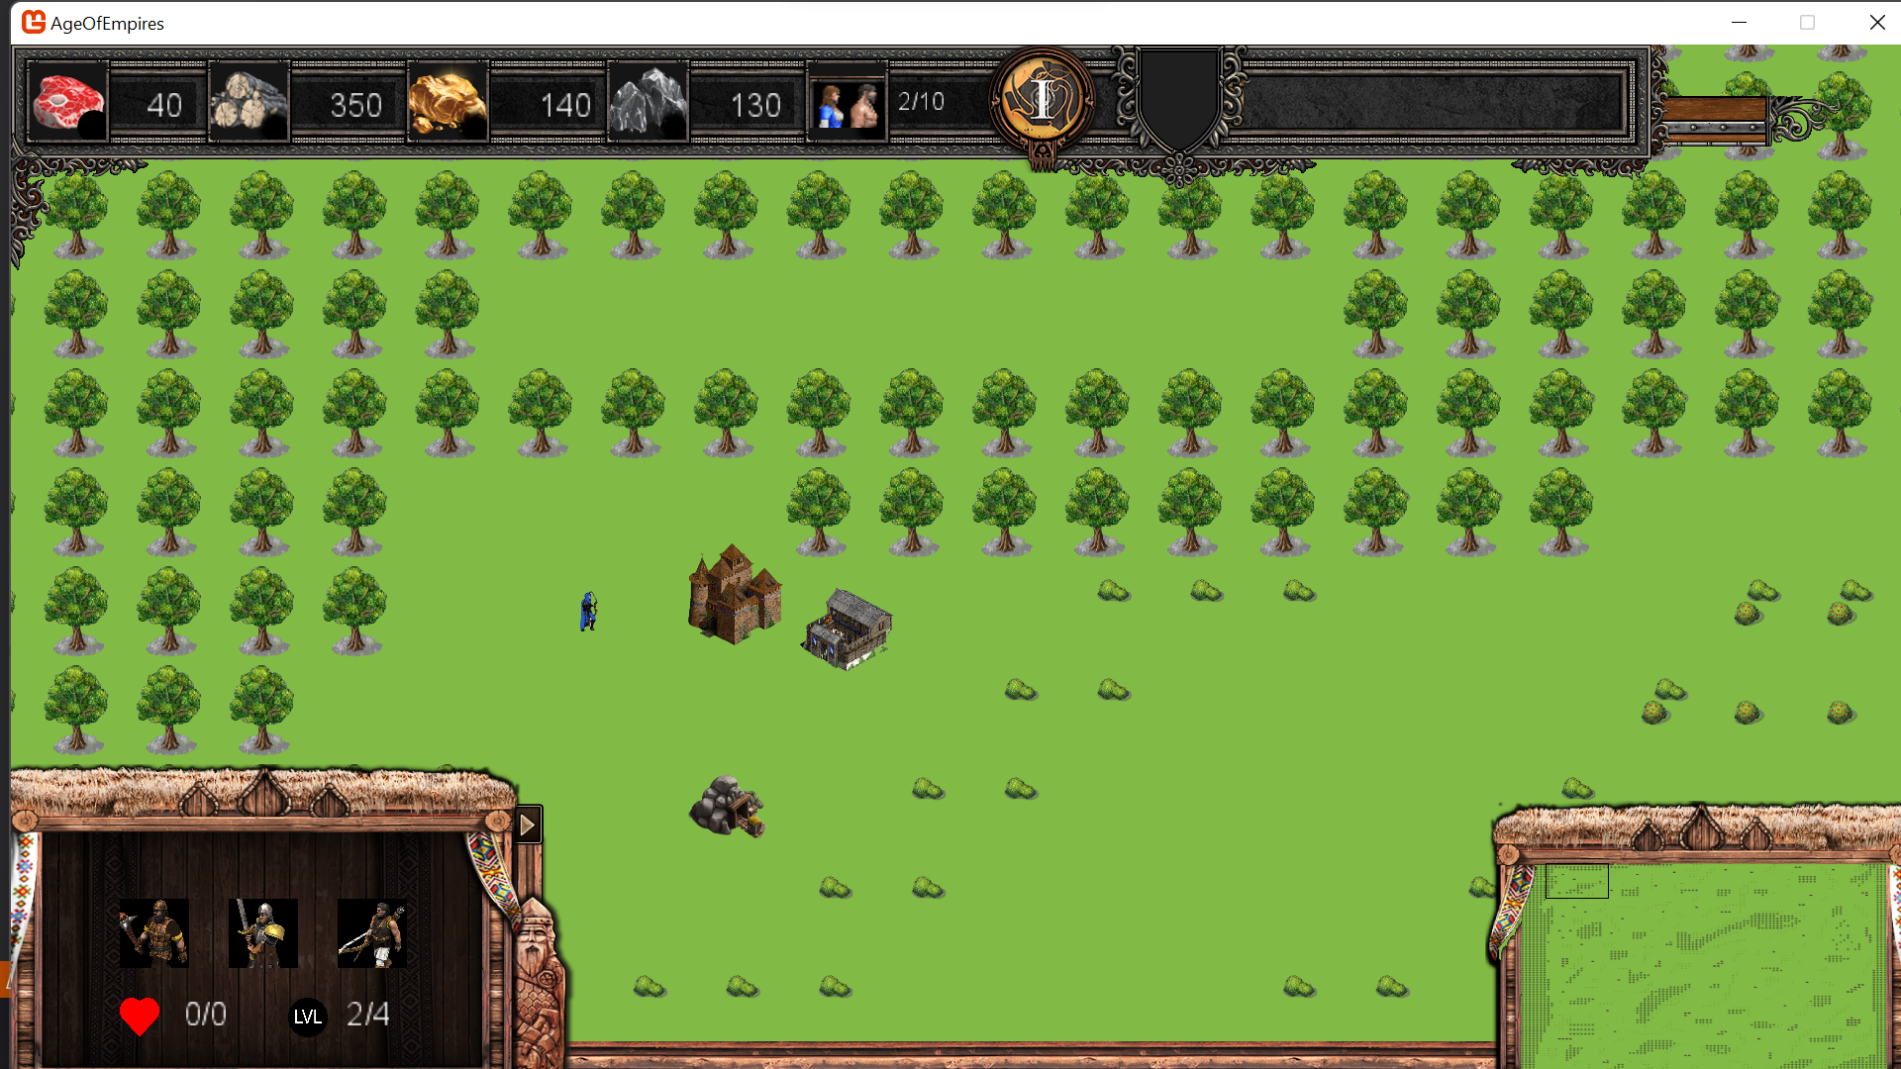

# MoSCoW

A MoSCoW list will be used to further elaborate and show exactly what we plan to have in Empires of Ages

## Must-Have

* 2D graphics
* 1 enemy while playing
* Game controls of top-down click and drag-style
* 1 Map
* Gold resources
* Stone resources
* Food resources
* Wood resources
* Stats display
* The ability to create extra villagers
* The ability to create military
* The ability to upgrade
* Ability to attack
* Ability to grind
* Ability to create farm, buildings, barrack
* Factions with same units

## Should Have

* 2 or more factions ( based on real nations)
* Factions with their own units
* Animations
* Mirroring animations depends on the movement
* Start and quit button on the menu
* Fixed capacity resources (disappears if it is empty)
* Armor
* More than 1 type of soldier

## Could Have

* Multiple playable factions
* Wild animals
* Weather
* Time of day
* Fishing and boats
* AI enemy

## Won’t Have

* One campaign
* Multiplayer
* More than 1 campaign
* 3D graphics
* Realistic graphics

# Required sources, frameworks

Monogame

Monogame extended

Visual Studio 2019 is recommended (2022 version cannot work properly with Monogame)

.NET desktop development

.NET cross-platform development

# Sources

List of C# and .NET game engines and frameworks. (2018, November 1). AlternativeTo. Retrieved April 23, 2022, from <https://alternativeto.net/list/6695/list-of-c-and-net-game-engines-and-frameworks/>

MonoGame. (2009, January 1). MonoGame. Retrieved April 23, 2022, from <https://www.monogame.net/>

Wiki Targeted (Games). (n.d.). Age of Empires Series Wiki. Retrieved April 23, 2022, from <https://ageofempires.fandom.com/wiki/Age_of_Empires>